MiniProject 1 – Part 1
Semantic Similarity and Information Retrieval

1. Introduction
This project investigates how different embedding techniques affect semantic similarity and information retrieval performance. By implementing cosine similarity and comparing multiple embedding models, this study aims to bridge theoretical concepts with real-world applications.
Specifically, we examine GloVe word embeddings, Sentence Transformer embeddings, and OpenAI embeddings to analyze their effectiveness in capturing sentence-level meaning.

2. Experimental Setup
2.1 Categories
The following categories were used in the experiment:
Flowers, Colors, Cars, Weather, Food
2.2 Input Sentence
The input sentence for evaluation was:
"Roses are red, trucks are blue, and Seattle is grey right now"
2.3 Embedding Models
Four embedding models were evaluated:
- GloVe (50 dimensions)
- Sentence Transformer (all-MiniLM-L6-v2, 384 dimensions)
- OpenAI text-embedding-3-small (1536 dimensions)
- OpenAI text-embedding-3-large (3072 dimensions)
All models were compared using cosine similarity, and results were visualized using pie charts.

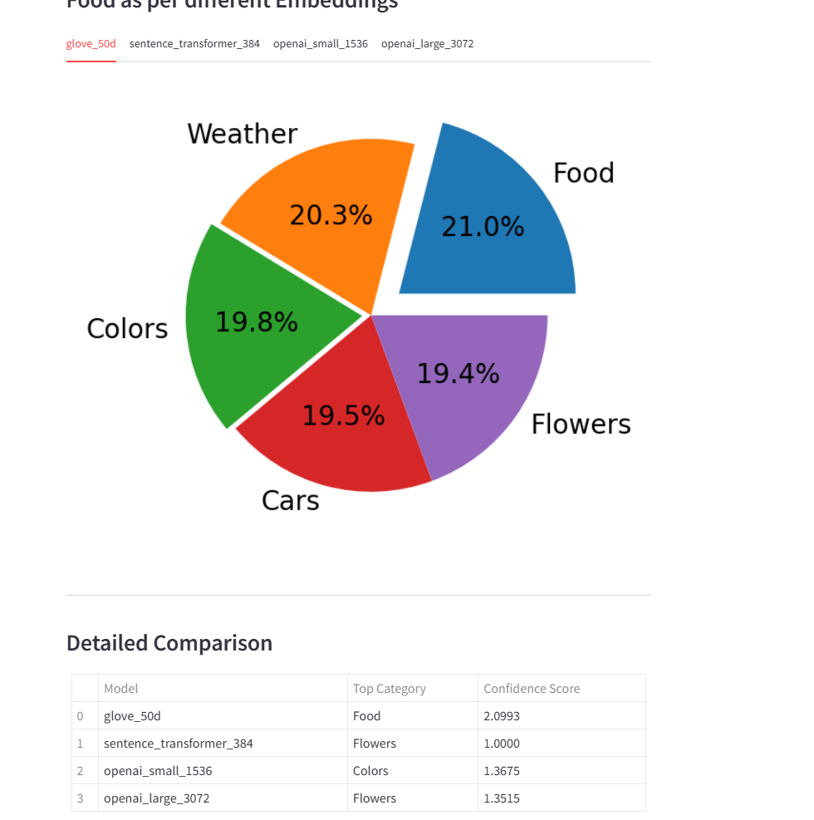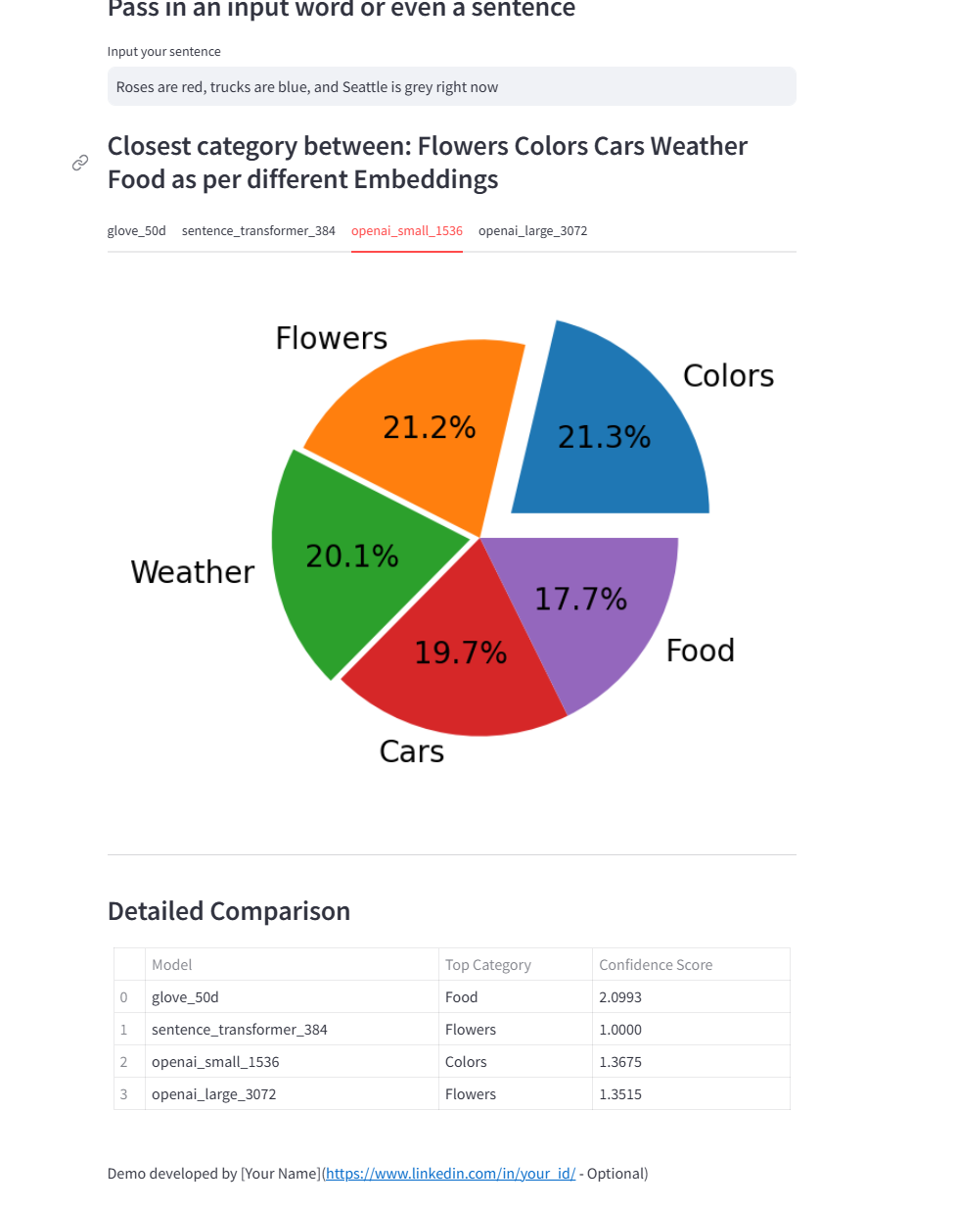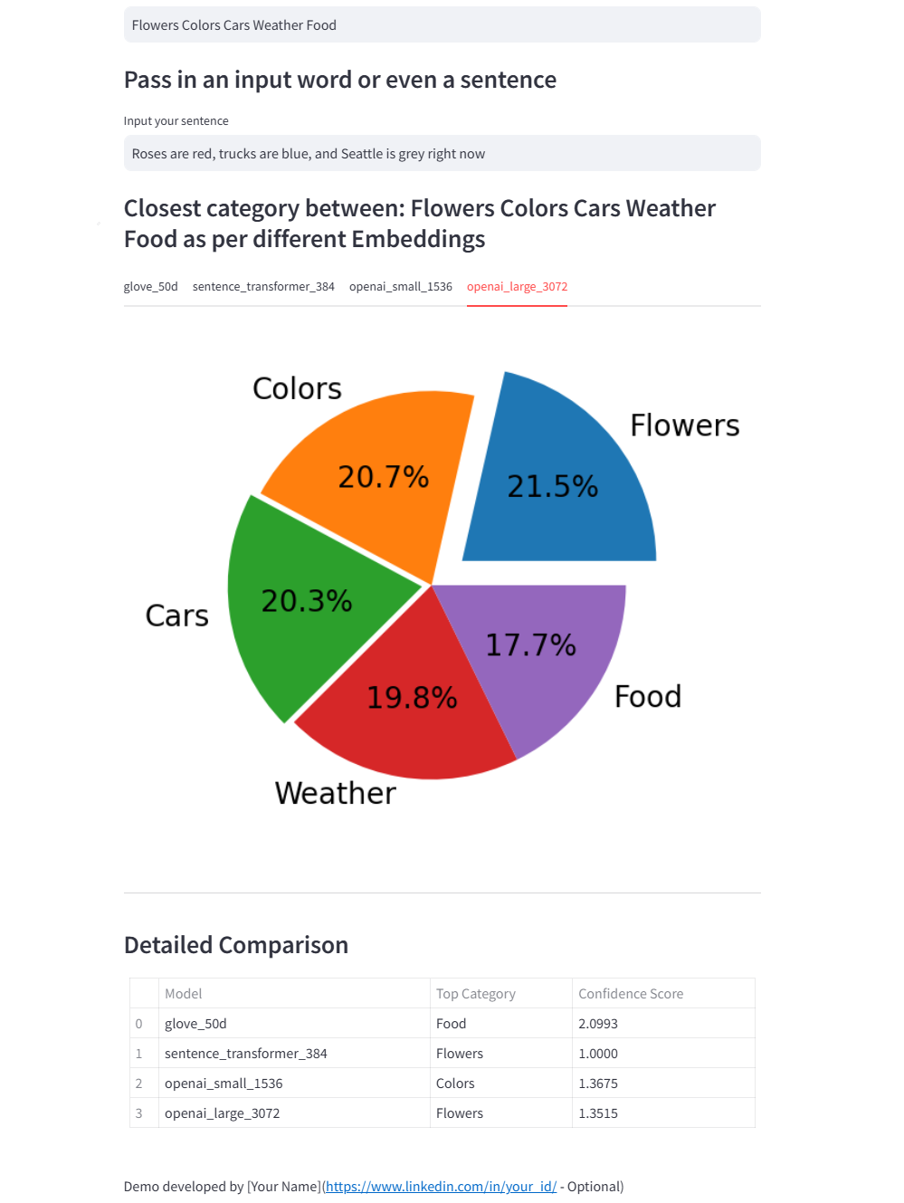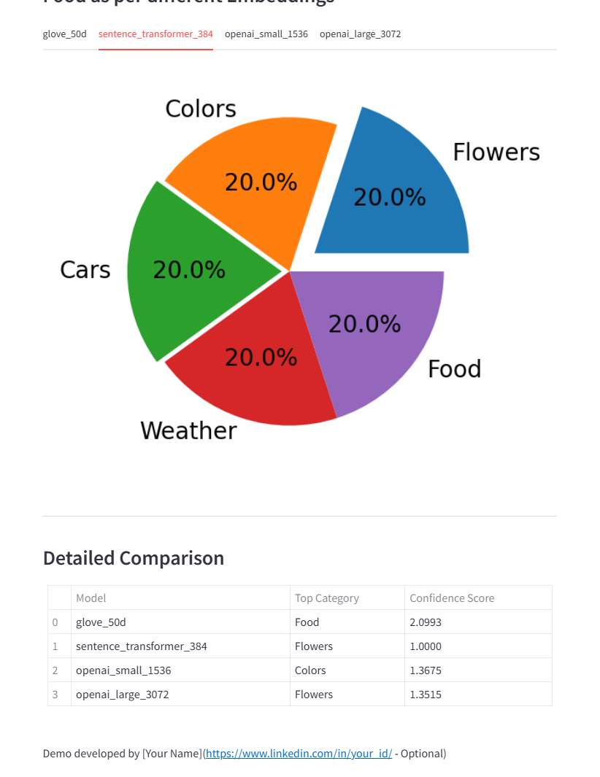

3. Part A: Model Performance Analysis
3.1 Accuracy Evaluation
The top categories and confidence scores obtained from each model are summarized below:
GloVe (50d): Food (2.0993)
Sentence Transformer: Flowers (1.0000)
OpenAI Small: Colors (1.3675)
OpenAI Large: Flowers (1.3515)
Sentence Transformer and OpenAI Large correctly identified "Flowers" as the most relevant category, reflecting their ability to capture semantic emphasis from the word "Roses".
OpenAI Small emphasized color-related words such as "red", "blue", and "grey", resulting in "Colors" as the top category.
GloVe showed unstable behavior due to noise introduced by averaging individual word embeddings.
3.2 Error and Failure Analysis
GloVe embeddings lack contextual awareness and rely solely on word-level statistics. As a result, important semantic relationships between words are ignored.
In contrast, transformer-based models utilize self-attention mechanisms to encode contextual dependencies, significantly reducing semantic ambiguity.
3.3 Word Order Sensitivity
GloVe treats sentences as unordered collections of words, leading to similar embeddings for sentences with different word orders.
Sentence Transformer and OpenAI embeddings preserve word order and contextual relationships, allowing them to distinguish subtle semantic differences.

4. Part B: Model Comparison
A comparative analysis of the models is presented below:
GloVe:
Dimensions: 50
Accuracy: Low
Speed: Fast
Word Order Sensitivity: No
Sentence Transformer:
Dimensions: 384
Accuracy: High
Speed: Medium
Word Order Sensitivity: Yes
OpenAI Small:
Dimensions: 1536
Accuracy: High
Speed: Medium
Word Order Sensitivity: Yes
OpenAI Large:
Dimensions: 3072
Accuracy: Very High
Speed: Slow
Word Order Sensitivity: Yes
These results demonstrate a trade-off between computational cost and semantic accuracy. Higher-dimensional models generally achieve better performance at the expense of increased latency.

5. Part C: Real-World Applications
To evaluate real-world relevance, three groups of everyday categories were analyzed.
Group 1: Kitchen / Baby / Furniture
- baby safety cabinet lock
- cabinet lock for baby safety
The first sentence emphasizes baby products, while the second focuses on furniture accessories.
Group 2: Outdoor / Sports / Travel
- outdoor camping tent for family
- family travel tent outdoors
The first sentence highlights recreational use, while the second emphasizes travel-related context.
Group 3: Technology / Education / Office
- student laptop for online learning
- online learning laptop for students
The first sentence focuses on student usage, whereas the second emphasizes educational environments.
These examples illustrate how word position and emphasis influence semantic interpretation.

6. Discussion
The experimental results indicate that contextual embedding models significantly outperform traditional word-averaging approaches. Transformer-based architectures enable robust semantic representations by modeling long-range dependencies.
Furthermore, OpenAI Large demonstrates superior performance due to its high dimensionality and large-scale training data, making it suitable for production-level retrieval systems.

7. Conclusion
This project demonstrates that embedding selection plays a critical role in semantic similarity tasks.
GloVe embeddings are limited in sentence-level understanding, while Sentence Transformers and OpenAI embeddings provide strong contextual modeling capabilities.
For real-world information retrieval systems, transformer-based embeddings are recommended due to their accuracy and robustness.

